Words You Know
Mrs. Pino
Prefixes and Suffixes Word Bank
believable, breakable, careless, comfortable, desirable, doable, flexible, invention, location, trainable
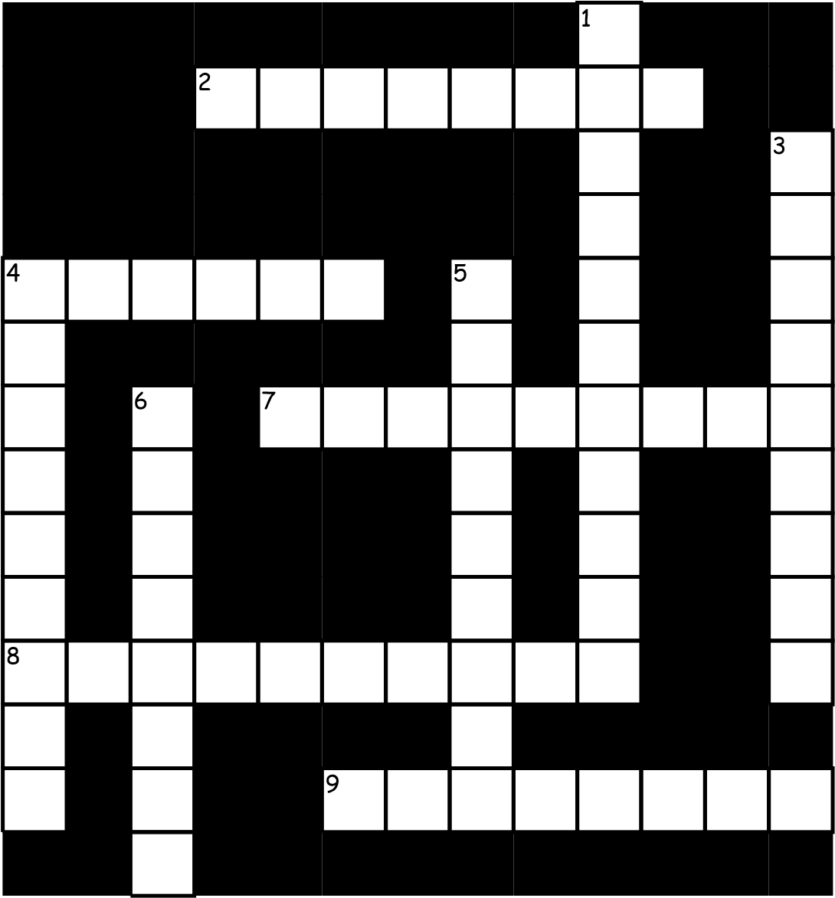

Across
2 I know the ________of 1
Canada on a map of
North America. 3
4 Cleaning up the yard is easy and ______. It's a job I hand handle well!
- If you create an 4
_______like an airplane, or a cell phone, or a
computer, then one day
you will be famous. 5
- My friend is a person
who always tells the 6
truth. That is why her stories are____.
- Cats can roll, bend, and stretch. Their bodies are very _______.
Down
My bed is very soft, and _____. Some pets and other animals can be _____. But others, like a shark, or snake, are not. When I go shopping, there are many exciting things I would like to buy or own. They are so _____.. A glass vase is a______object. When I am not responsible with my school supplies, and lose them, then I am ___.

