Homework Calendar for the week of March 23, 2020 Room 202 2nd grade
This week in spelling, you will review the words you have had in the last month. There are many words, but you will recognize them.
Reviewing the words will be an important learning experience.
Monday | Tuesday | Wednesday | Thursday | Friday
Spelling:  1--Today spend 15 minutes reading all the words you had in the last month.  Read each word, read the sentences under each word, and repeat this activity.  This is considered a “Reading” activity because you are reading the words in context and reading for understanding. | Spelling:  1--Today spend a few minutes reading the list of spelling words. Remember it’s considered a “Reading” activity.  2--Complete the Crossword puzzle. It’s Okay if another family helps you with the clues and sentences. | Spelling:  1--Complete the word search puzzle:  I provided…but, remember you can create your own (as well). If you make your own, give it to another family member to complete it. | Spelling:  1-Write a friendly letter. Include as many spelling words as possible.  Example:  March 23, 2020  Dear Ethan,  I had a restless night thinking of all the school assignments I need to complete. But I think I can handle them. They seem easy and doable. I am also spending more time with my pet dog-Rusty. Rusty is a friendly dog. I will teach him some new tricks. He obeys my commands. That’s why I know he’s a trainable pet.  Well, that is all the news I have for now.  Take care!  Your friend,  Allen | Ask a family member to test you on some of the words. Select 8 words. Can you spell them?

Spelling Words (Words that contain the suffixes “ble” and “tion”)
Break able  Breakable  Some objects can be fragile and breakable like a crystal water glass.  Break  Breaking  Broke  Breaks | Believe able  Believable  Magicians spend much time practicing their magic tricks to make them appear (or seem) believable.  .Believe  Believing  Believed  believes | Flex ible  Flexible  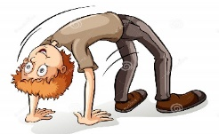  Ben has a flexible body because he can bend it easily and position it in different ways.  Flex  Flexing  Flexible  Flexed  Flexes | Invent ion  Invention  The Wright Brothers were clever pioneers! They were the first to invent the airplane.  After their plane invention, they became famous.  Invent invented  Inventing invents | Locat ion  Location  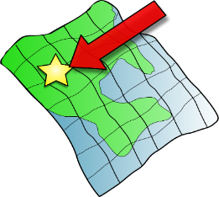  This map will help me find the location (place) of my meeting.  Locate  Located  Locates  Locating

1-Comfortable  Comfort “able”  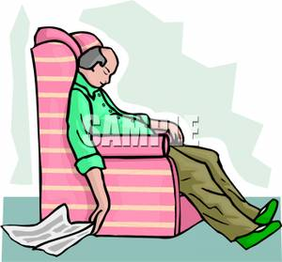  Grandpa’s chair is so comfortable, that he ends up falling asleep each time he sits to relax. | 2- doable (to be able to do)  do “able”  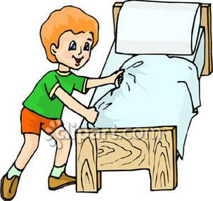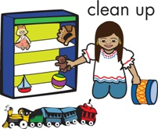  “These jobs are easy and doable,” said Mark to Katie. “I’ll be able to do this again anytime!” | 3- trainable  train “able”  My pet dog is trainable.  He quickly and easily learns new tricks! | desirable (wantable)  desire “able”  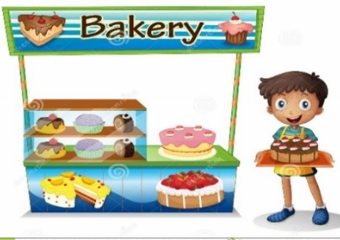  The pastries and treats at a bakery are desirable!  I feel like tasting one now!
Careless  Care less  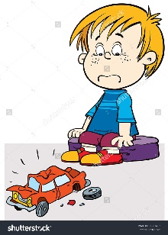  Dan was careless with his toy car. That’s why it’s broken. | 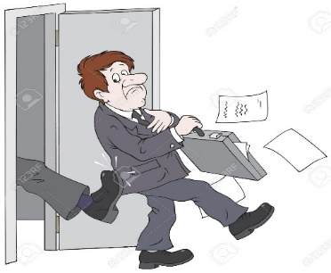  jobless  job less  Mr. Smith was fired from his job. Now he is jobless. He is without work. | flawless  (without a mistake)  This tricycle has a design flaw. A flawless tricycle | restless  (without rest)  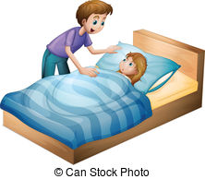  Lesly is afraid of the dark. This is why she is restless at night during bedtime.

The suffix (or word ending) “ed” can sometimes be tricky. “ed” at the end of words can sound like a “t,” like a “d” or… “id.”
deposit = (putting in)
1-baked (bake) “t”  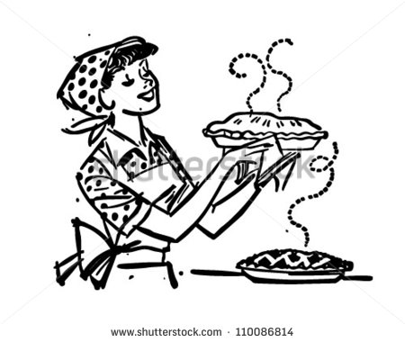  Mother baked our favorite pie for dessert. | 2- hiked (hike) “t”  Michael hiked a steep mountain path. | 3- Sighed (sigh) “d”  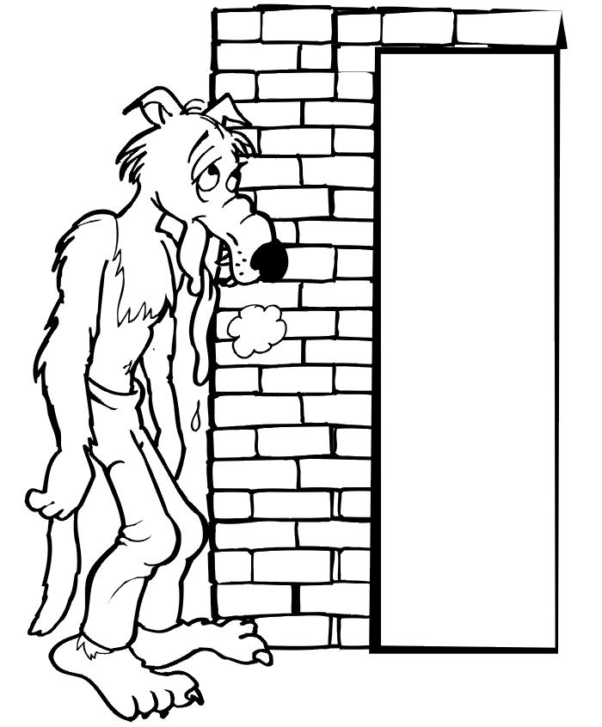  The wolf sighed after blowing with great force. | Served serve  The Chef served dessert to all the guests at the party.
4- - cried (cry) “d”  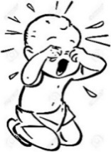  Gary cried after hurting himself as he crawled.  crawl | 5--Squinted (squint) “id”  Elizabeth squinted when she stood under the bright sun. | 6-- counted (count) “id”  Mr. Anderson counted his money before depositing his in the bank. | Lifted lift  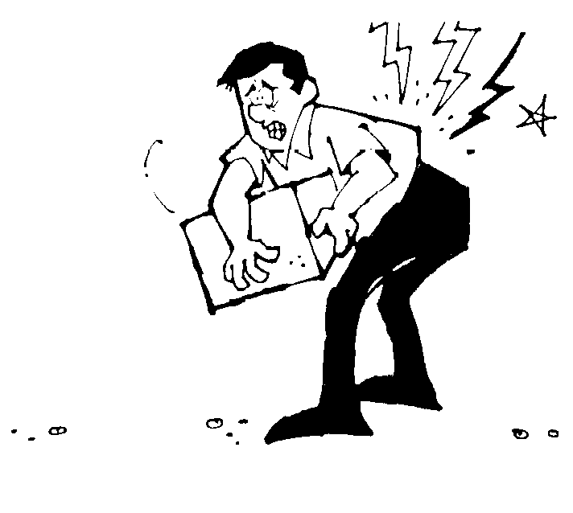  My father injured his back when he  lifted the heavy box.

1-Dislike ( dis = no not)  I dislike cleaning the house!  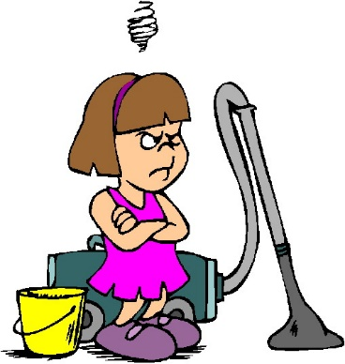 | Disappear  The magician can make the coin disappear. | Prepay (pre= before)  Father will use his Visa card to prepay for our plane tickets. | Pretest  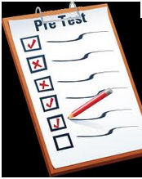  Today we will take a pretest, so that we know which words to practice for the real test tomorrow.
Unfair (un = not)  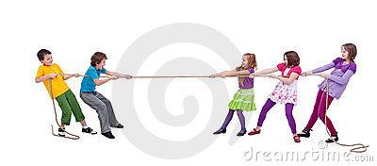  It’s unfair that one team has more members than the other. | Unsafe  It is unsafe to retrieve the boxes without using a ladder.  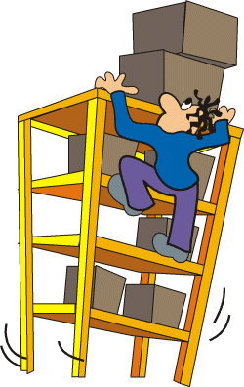 | Uneven un even  even ground 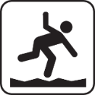 uneven ground  Someone can trip over the uneven ground surface. | Biweekly (bi = 2)  My biweekly swim lessons will help me stay strong and healthy. Attending swim lessons twice-a-week helps me stay in shape!  