Day of the Week | Reading/spelling/phonics | Writing | Mathematics | Science or social studies:
Monday  March 23, 2020 | 1-Students will complete 2 pages in the Sing, Spell, Read and Write book. It’s the pink workbook the students took home (on Monday, March 16th). Those few who did not take it home can pick it up from the main office. Please call the office first.  2-Students will read from any of the following choices: 1. Raz kids.com 2- A book that the teacher gave you (on Monday) 3- a book from home 4-a reading passage from any of the ones I have included for this week.  Students will select 5 questions to respond to (in a notebook).  Please look at the page with the list of questions.  Remember: You are also reading to improve on these skills:  *fluency *accuracy (punctuation and expression) *comprehension (understanding what you read)  3-Log on to Iready.com to complete assigned lessons for today.  4-Complete the assigned spelling activity (like it describes on the homework calendar). This week you have words that contain suffixes. | This week, we will review –Facts and Opinion. We learned about “facts,” and “opinions” earlier this year, but this would be a good time to review.  The writing assignments will be attached to these plans (with the date), and you can print them, or write in a notebook.  Choice 1 (The purpose of this lesson is to review Facts and Opinions)  Choice 2 (facts and opinion)  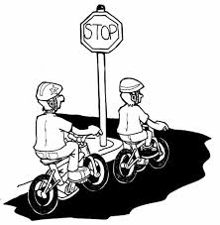  Also…for enrichment and more writing practice…  With an adult’s permission, and supervision, the second grader can visit:  www.teachingwithoutfrill/informationalwriting.  Students can revisit episodes 1, and 2, and begin episode 3. In Episode 3 (the lady talks about “subtopics.” The subtopics are the “headings.” In class you have learned that the “headings” are in the table of contents.  (Just like the headings in your animal book that you started working on in the classroom).  If you are enjoying this website, go ahead, and try the activity.  - Think of a topic (a real topic—just like the lady is showing you in episode 2---the lesson on “brainstorming”)  - Do the activity for episode 3 (Make a plan)  Remember to repeat the video a few times if you need to (or to remember the steps)  You will need paper, or notebook for this assignment.  DO NOT GO AHEAD. TAKE YOUR TIME. PAY ATTENTION TO YOUR WRITING, CHECK YOUR WORK.  Don’t try to complete all the episodes in 1 day. | 1-Students need to complete the Iready.com Math lesson for today.  2-Students can also complete 2 math tasks included in their homework calendar-for this week.  3-Students can complete 1 page from the Envision math pages they took home (topic 9)  Lean the new math vocabulary.  It’s important that an adult, or older sibling be with the student to help- with the vocabulary and completing lesson 1 of topic 9  Place your math word cards for topic 9 in a zip bag so that you can continue practicing the words. | Visit:  Mysteryscience.com  Look under  School closure planning  Follow the instructions  You should have access to the lessons.  Please click on second grade lessons  BEGIN WITH..  Are Unicorns Real?  DO NOT TRY TO DO ALL THE LESSONS.  Be reflective about what you learned today (on unicorns)  Write a short “retell” about what you learned. Keep your work or writing in a notebook.  You can say something like…  Today in the lesson:  Are Unicorns real?.. I learned 3 important facts. These are the facts I learned…  1._____  2._____  3._____
Tues  March 24, 2020 | 1-Students will complete 2 pages in the Sing, Spell, Read and Write book.  2-Students will read from any of the following choices: 1. Raz kids.com 2- A book that the teacher gave you 3- a book from home 4-a reading passage from any of the ones I have included for this week.  Students will select 5 questions to respond to (in a notebook).  Please look at the page with the list of questions.  Remember: You are also reading to improve on these skills:  *fluency *accuracy (punctuation and expression) *comprehension (understanding what you read)  3-Log on to Iready.com to complete assigned lessons for today.  4-Complete the assigned spelling activity (like it describes on the homework calendar for this week) | Once again today (Tuesday) you will practice reading and writing about facts and opinion.  1-Select a writing activity. (The content of these activities comes from the website: www.superteacherworksheets)  2-You can print the activity, or have your notebook ready (paper and pencil). You can choose to complete the whole practice sheet, or… complete 10 sentences (from this sheet) but you will need to think of 6 more sentences to write. Think of 3 more facts about animals, and think of 3 opinions you have about animals. (Write a total of 6 sentences).  The assignment will have this picture, or image on it.  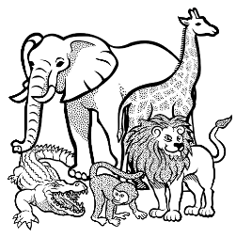  Extra Writing Practice (for enrichment)  For those of you who started viewing the video  www.teachingwithoutfrill/informationalwriting, please review  Episodes 1, 2, and 3. If you think you are ready for episode 4 (writing an introduction) -- you may begin episode 4 (with a parent or adult nearby to help). | 1-Complete the Iready.com Math lessons assigned for today.  2-Complete 1 or 2 math tasks (from the homework calendar for this week)  3-Take your student coins  (the play money you took home on Monday)  Practice naming the coins and counting different groups of coins. | - If you didn’t complete the diorama project from last week. You should try it. Some students have sent me their pics.  You can continue with the mystery science lesson (from where you left off yesterday.  Remember, you need to do a “retell” of what you learned.  Keep your work in a notebook.
Wed  March 25, 2020 | Reading:  1-Log on to the assigned iready lessons.  4-Complete the crossword puzzle using the spelling words.  Ask a family member to help you. If you don’t have a printer, write the answers on paper, or a notebook. | Writing for today (Wednesday)  Look for this writing activity, and complete it. (It’s on Facts and Opinions.  Extra Writing Practice (for enrichment)  For those of you who started viewing the video  www.teachingwithoutfrill/informationalwriting, please review  Episodes 1, 2, 3, and 4. Check your introduction, see if it makes sense. Check your writing. If you think you are ready for episode 5, You may begin episode 5 (with a parent or adult nearby to help). This episode is about writing a draft (here you will write about the headings. You will need to think of important details for your headings).  Remember, please, please take your time. Do not rush!!! It will be important to work with an adult nearby to help. | 1-Complete the Iready math lessons that have been assigned for today.  2-Did you complete all of the math word problems and math tasks for this week? If you haven’t  This would be a good day to try completing the math word problems and math tasks I assigned for this week. | Complete the diorama or desert project.  Discuss with it with family members.  Think of questions to ask.

Thurs  March 26th | Reading:  1-Log on to Iready reading  2-Complete the 2 pages from Sing, Spell, Read, and Write. (Do not rush) check your work. Reread the pages you completed  3-Read any book you have for entertainment.  4-Complete another activity (included in the homework calendar)  5—Read about your “famous woman”  Perhaps you can have your parent dress you up like her. Be creative!!  Super creative!!  Email me a photo. But write something about your famous woman  You can follow the format below (this is a suggested format)  Example:  Meet Me, ______  I am famous because____  Did you know that I ______  I also _______________  Lastly, I __________  A real example would look like this…  Meet Me, Mother Teresa of Calcutta  I am famous because I lived most of my live helping the poor, the sick, and needy people of my community.  Did you know that I won the Nobel Peace prize? But, instead of keeping the prize money for myself, I asked that it be given to the needy.  I also traveled around the world to tell people how important it is to help others.  Lastly, I want people to follow my example and stay proactive to make this world a better world! | Today, Thursday,  1--Make a Cootie Catcher  About Facts and opinions or…  2—Pick a family member. Write 5 or 6 facts about that person. Then write some opinions about the person. For example:  brother  Fact: My brother has brown hair.  Opinion: My brother is the best soccer player in our community.  I included the instructions on how to make a  cootie catcher  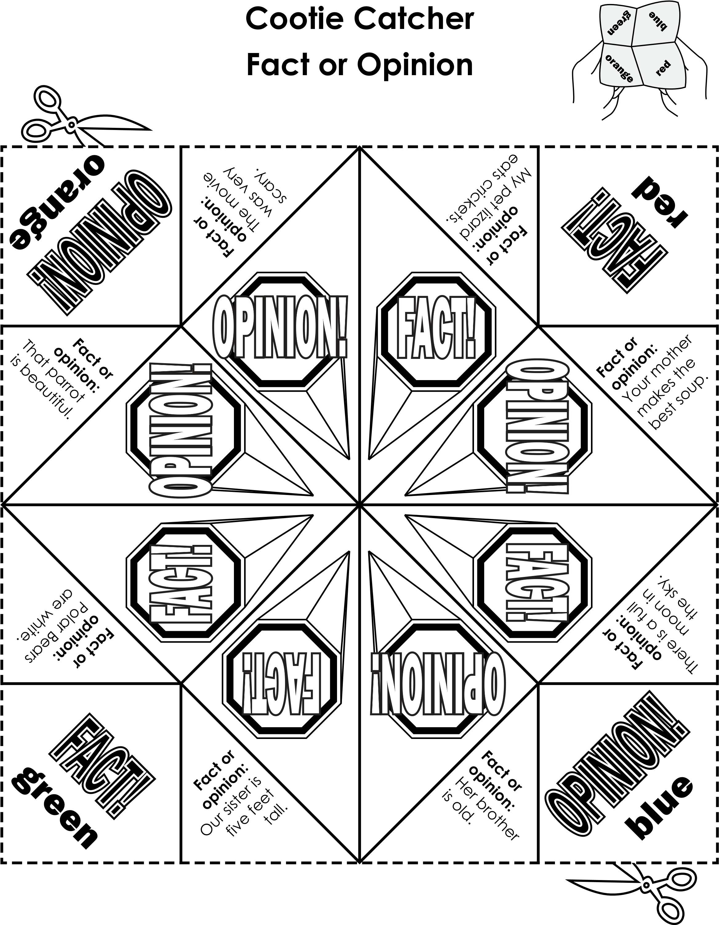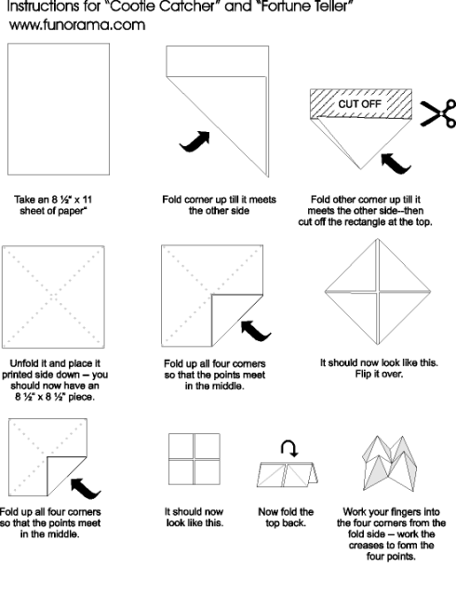 |  | Continue with another Mystery science lesson. Preferably from where you left off.
Friday  March 27th | Reading:  1-Log on to Iready reading  2-Complete the 2 pages from Sing, Spell, Read, and Write. (do not rush) check your work. Reread the pages you completed  3-Read any book you have for entertainment.  4-Complete another activity (included in the homework calendar) | Writing Activity: (Halloween Costumes)  Today you will write facts and opinions about Halloween costumes.  This is what the activity looks like:  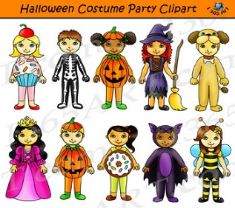  Or…  On a notebook, draw the best Halloween costume you can think of and explain why it’s the best (in your opinion).  You might begin like this…  In my opinion, this is the best Halloween costume you will ever see and these are the reasons that tell why. |  | Work on the “Famous Woman” project that I suggested for “Thursday” of this week (under the “reading section”)  I think it will turn out to be a fun activity.  This was an activity we started in class, but now you can do it with the help of a parent.  The boys can join in and do a famous woman or famous man project as well. The second grade boys can follow the same format.  You can find information on your chosen person on this website:  www.ducksters.com  click on biographies.

