Day of the Week | Reading/spelling/phonics | Writing | Mathematics | Science or social studies:
Wednesday  March 18, 2020 | 1-Students will complete 2 pages in the Sing, Spell, Read and Write book. It’s the pink workbook the students took home (on Monday, March 16th). Those few who did not take it home can pick it up from the main office. Please call the office first.  2-Students will read from any of the following choices: 1. Raz kids.com 2- A book that the teacher gave you (on Monday) 3- a book from home 4-a reading passage from any of the ones I have included for this week.  Students will select 5 questions to respond to (in a notebook).  Please look at the page with the list of questions.  Remember: You are also reading to improve on these skills:  *fluency *accuracy (punctuation and expression) *comprehension (understanding what you read)  3-Log on to Iready.com to complete assigned lessons for today.  4-Complete the assigned spelling activity (like it describes on the homework calendar). This week you have words that contain suffixes. | 1-Complete a story. You will find these story choices following these lesson plans.  Choice 1  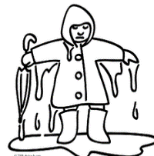  Choice 2  Also…  With an adult’s permission, and supervision, the second grader can visit:  www.teachingwithoutfrill/informational writing.  Students can view (or watch) episode 1 and episode 2. Students should not go beyond these two episodes.  Students need to be thoughtful and reflective about the information presented in these two You tube videos. | 1-Students need to complete the Iready.com Math lesson for today.  2-Students can also complete 2 math tasks included in their homework calendar-for this week.  3-Students can complete 1 page from the Envision math pages they took home (topic 9)  Lean the new math vocabulary.  It’s important that an adult, or older sibling be with the student to help- with the vocabulary and completing lesson 1 of topic 9  Place your math word cards for topic 9 in a zip bag so that you can continue practicing the words. | Log on to Raz Kids.com  Read the book  Animal Habitats
Thursday  March 19, 2020 | 1-Students will complete 2 pages in the Sing, Spell, Read and Write book. It’s the pink workbook the students took home (on Monday, March 16th). Those few who did not take it home can pick it up from the main office. Please call the office first.  2-Students will read from any of the following choices: 1. Raz kids.com 2- A book that the teacher gave you (on Monday) 3- a book from home 4-a reading passage from any of the ones I have included for this week.  Students will select 5 questions to respond to (in a notebook).  Please look at the page with the list of questions.  Remember: You are also reading to improve on these skills:  *fluency *accuracy (punctuation and expression) *comprehension (understanding what you read)  3-Log on to Iready.com to complete assigned lessons for today.  4-Complete the assigned spelling activity (like it describes on the | 1-Student will complete a story. You will find these story choices following these lesson plans.  Choice 1  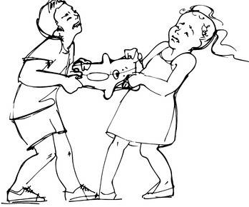  Choice 2  Also…  With an adult’s permission, and supervision, the second grader can visit:  www.teachingwithoutfrill/informationalwriting | 1-Complete the Iready.com Math lessons assigned for today.  2-Complete 1 or 2 math tasks (from the homework calendar for this week)  3-Take your student coins  (the play money you took home on Monday)  Practice naming the coins and counting different groups of coins. | 1-Today You can  Read and look over the color pages about animals of the desert (desert habitat/biome)  Create a diorama of the desert habitat or biome.  Color the animals and follow the instructions to complete the project.  Add more details that relate to this habitat or biome.
Friday | Reading:  1-Log on to the assigned iready lessons.  2-Log on to Raz Kids and find the book that has this title:  Introducing Planet Earth (It’s a level L book). It teaches you important details about Earth and the continents. In class, we have been learning about the continents.  The book will inform you, but it will also entertain you. Read twice.  *Ask a parent to help you read the book (if you need help), or the parent can read the book to you.  Complete the Comprehension quiz  3-Ask a family member to test you on your spelling words (in written form, and orally)  3-Create a Cutie Catcher and make a game using the spelling words.  4-Complete the crossword puzzle using the spelling words form this week and last week. Ask a family member to help you. If you don’t have a printer, write the answers on paper, or a notebook. | - Students will write an “opinion piece” like the one we completed in class. I’m hoping students will remember the structure of it. I will include an example.  In the classroom the topic was..  Should second graders take a cell phone to school?  Today you can choose from one of these:  - Should students be allowed to bring any snack to school?  - Should students be allowed to bring their pets to school on field day?  Also…  With an adult’s permission, and supervision, the second grader can visit:  www.teachingwithoutfrill/informational  Review episode 1 and 2  Students can start thinking about a topic to write about. It must be something the student knows enough about. | 1-Complete the Iready math lessons that have been assigned for today.  2-Did you complete all of the math word problems and math tasks for this week? If you haven’t  This would be a good day to try completing the math word problems and math tasks I assigned for this week. | Complete the diorama or desert project.  Discuss with it with family members.  Think of questions to ask.

