Landmarks from different continents of the World
1-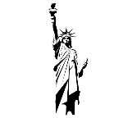 Statue of Liberty – New York City in the U.S.A (North America)
2- 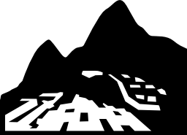 Machu Picchu - Peru (South America)
13---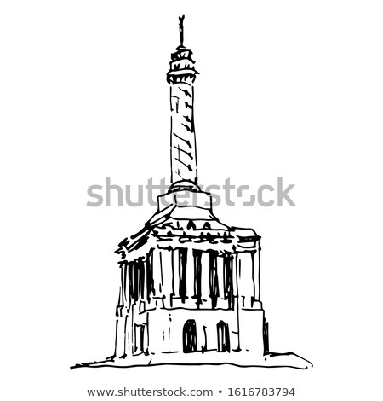 Monument to the Heroes of Restoration (in the Caribbean)- Dominican Republic in North America
14-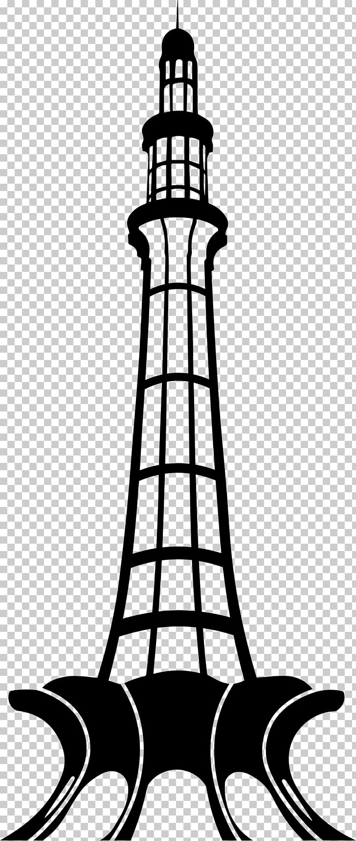 Minar-e-Pakistan (The Tower of Pakistan) in Pakistan, in Asia

3- 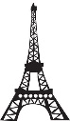 The Eiffel Tower—Paris France (Europe)
4-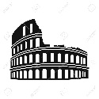 The Roman Colisseum-- Rome, Italy (Europe)

5-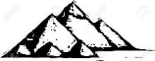The Eyptian Pyramids---Eygpt, (Africa)
6- 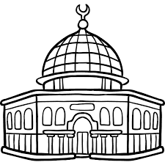 Dome of the Rock (Palestine/Jerusalem) Middle East (Asia)
7-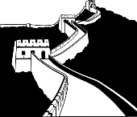 Great Wall of China China (Asia)
8-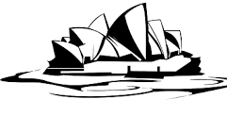 The Sydney Opera House Sydney (Australia)
9- 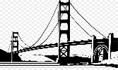 The Golden Gate Bridge, California (U.S.A) (North America)

10-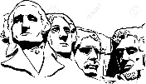 Mount Rushmore, South Dakota, (U.S.A.) (North America)
11- 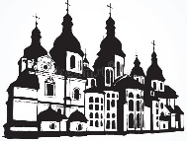 Saint Sophia Cathedral, Kiev, Ukraine (Europe)
12- Saint Basil’s Cathedral in Moscow, Russia (Europe and Asia)

Activities that your second grader can do independently or with another family member (anytime this week):

Social Studies:
(reviewing and/or revisiting the names of continents and using a compass rose (the cardinal directions—North South East West)

For this activity, invite the second grader to do the following activities:

Activity 1
(Supplies: the picture of the Word Map with the continents and the picture cards of the continents)

*Step 1---Spend a few minutes analyzing (or studying) the shapes of the 7 continents –on the world map. The map has the labels with the names of the continents.
*Step 2--Name the 7 continents
(1-North America 2-South America 3-Europe 4-Africa 5- Asia 6- Australia and 7-Antarctica)

*Step 3----The students can cut out the picture cards of the continents and practice naming and matching the picture cards of the continent with the ones on the map of the world. If you are not printing these activities, your child can practice matching by pointing, or writing the number of the card and writing the name of the matching continent next to it.

Activity 2
(Supplies: the picture of the World Map with the continents and the Compass Rose with cardinal directions)

Step 1 –Have the students look over the world map (with the names of the continents). He/she should review naming the continents and practice memorizing their shapes.

Step 2—The students can practice filling in the information to complete the sentence.

Activity 2 (identifying the location of continents –using the compass rose and cardinal directions

For example, look at the example below…
You can say (or write)
- “North America is located north of South America. “

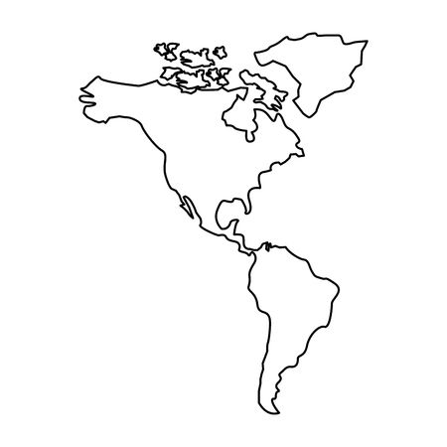
North
America
South
America
If you look at the location of North America, you will notice (or see) that it is north on this map.

South America is south, on this map.

Now it’s your turn.
- Africa is located _____ of South America.
- Europe is located_____ of Africa.
- Africa is located _____of Europe.
- South America is located ____ of North America.
- Asia is located ____ of Europe.
- Australia is located ____ of Asia.

Repeat this activity a few times to build your confidence and understanding.

Activity 3 Compass Rose 2

Students can revisit the compass rose and cardinal directions in a more sophisticated manner.
In this activity, the students will review the meaning of each letter and the added “partner letters” (like “NE”). Then they can use this compass to do Activity 2 (finding the locations of the continents). Look at the examples, below.
Supplies for this activity.
- The map of the world with the continents
- This compass rose.

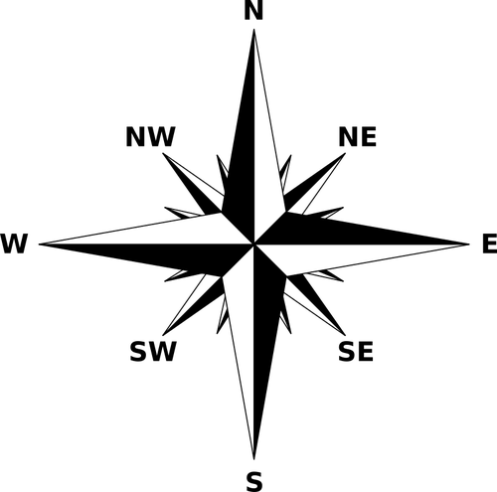

N = North S = South E = East W = West
NE = northeast SE = Southeast SW = southwest NW = northwest

Study the example below

Activity 3 (using the world map with the continents and the compass rose and cardinal directions)

Supplies for this activity.
- The map of the world with the continents
- Compass Rose 2 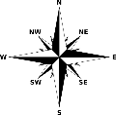

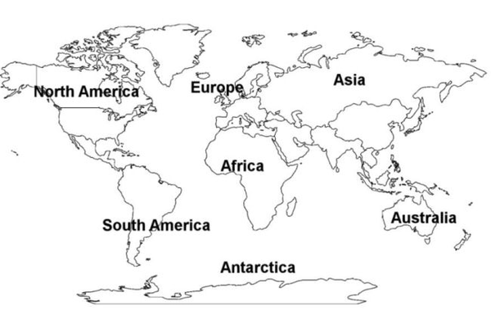

Here is an example:
“The continent of Antarctica is located southwest of Australia.

Now it’s your turn.
Use the map of the world with the continents, and the large picture of the compass rose to complete these sentences. Repeat this activity as many times as possible to build your understanding.

Activity 3 (using the world map with the continents and the compass rose and cardinal directions
1. The continent of South America is located ______of Africa.
2. The continent of Antarctica is located ______ South America
3. The continent of North America is located ______of Africa.
4. The continent of Africa is located ______of Asia.
5. The continent of Africa is located ______of Australia.
6. The continent of Antarctica is located ______of Asia.
7. The continent of South America is located ______of Europe.

- The continent of Asia is located ______of Africa.

- The continent of Europe is located ____of Australia.

- The continent of North America is located _____ of Antarctica.
Can you think of other examples?

A Compass Rose (and the cardinal directions)

N

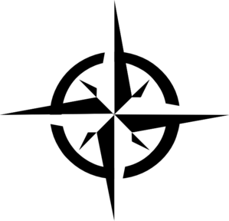
W
E
S

N = North S = South E = East W = West
Picture of World Map with the 7 continents
Continent 1 | 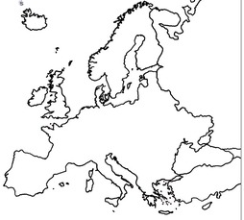  Continent 2 | 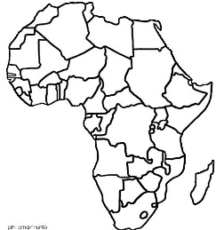  Continent 3
Continent 4 | Continent 4 | Continent 5
 | Continent 6

Activity 4 Supplies: use the “Landmarks” of the world (sheet) to see a picture of the landmarks and to know their locations. Use the picture cards of the landmarks, and the “Riddle” reading cards to learn more about each of the landmarks. You can read the Riddle cards and match it to the correct landmark picture. (If you have a printer, print the pages), or write the information in a notebook.

o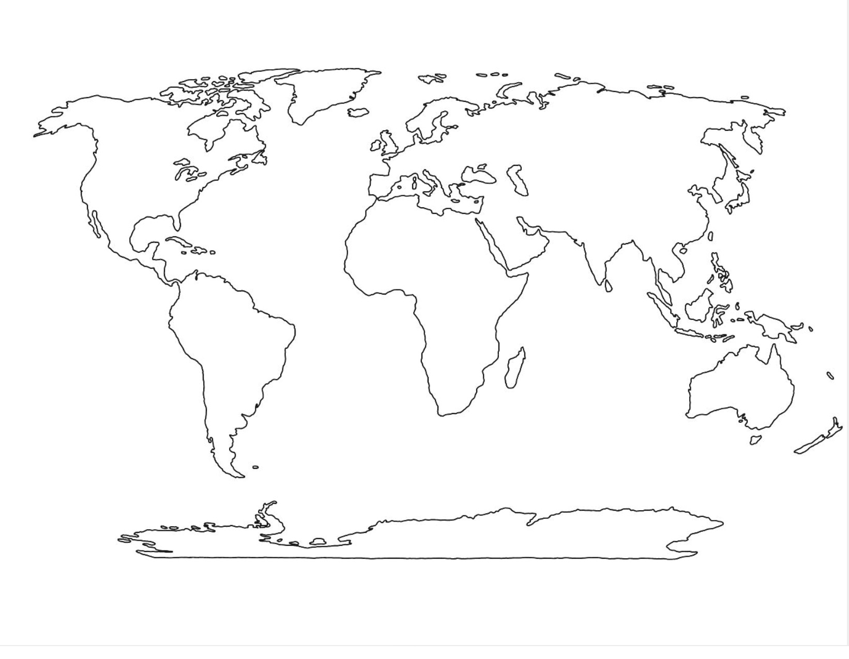
A
PAK
U
D
CH.
J
SD
R
E
I
P=
F
N
C
C = California ----Golden Gate Bridge (North America)
N = New York ----Statue of Liberty (North America)
P= Peru ----- Machu Picchu (South America)
F = France --- The Eiffel Tower (Europe)
I = Italy –---The Roman Colossum (Europe)
E = Egypt---- The Great Pyramids (Africa)
A= Australia ---- The Sydney Opera House (Australia)
R= Russia -- Saint Basil’s Cathedral (Europe)
SD= South Dakota (U.S.A)--- Mount Rushmore (North America)
J = Jerusalem –---Dome of the Rock (Middle East) (Asia)
CH = China ----- The Great Wall of China (Asia)
D = Dominican Republic----Monument to the Heroes of Restoration (North America)
U = Ukraine ---Saint Sophia Cathedral (Europe)
PAK= Pakistan--- Minar-e-Pakistan (Asia)

Landmark Picture Cards
The Golden Gate Bridge | Machu Picchu | The Eiffel Tower | The Statue of Liberty
Roman Colosseum | The Sydney Opera House | Saint Basil’s Cathedral | The Great Pyramids
Great Wall of China | Dome of the Rock | Mount Rushmore | 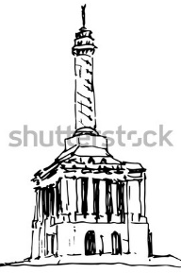Monument to the Heroes of Restoration
Saint Sophia Cathedral | 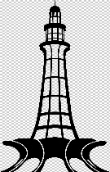  Minar-e-Pakistan

“Riddle” reading cards about the landmarks of the world.
Card A  I am a large statue like the size of a tall building, or skyscraper. I wear a crown. The crown has seven spikes. These 7 spikes represent the 7 continents. I am located in New York Harbor (on a small island). The name of this island is Liberty Island. New York city is located in the continent of North America. Where is North America on the world map? | Card B  We were 4 famous presidents of the United States of America. We became famous for the hard and important work we did when we were presidents. Our faces are carved on a cliff. A cliff is made of rock (like a mountain). Each face is about 60 feet tall. This cliff is located in the state of South Dakota in the continent of North America. Where is North America on the world map?
Card C  I am a very beautiful cathedral. A cathedral is a huge and magnificent building (or church) where people come to pray or worship.  I am famous for my “onion-shape” towers. I am very colorful from the outside. I am in the city of Moscow, Russia. Russia is the largest country in the world. But wait! Since Russia is so large, part of the Russia is in Europe, and the other part is in Asia. I am located on the side of Europe. Where is Europe on the world map? | Card D  I am located in the high mountains of the country of Peru. I am a very old city. I was built with stones. All around you will see large stone walls and ruins because no one has lived here for hundreds of years. But, I am like a hidden treasure. People from all over the world come to visit me. They must climb the mountain to see this beautiful sight. I was built by a group of people known as the Incas (the Incas were the “natives” who once lived there). This very old “stone” city is located in the continent of South America. Where is South America on the world map?
Card E  I am a large tower made of iron. Iron is a very hard metal.  I stand tall in the beautiful urban city of Paris. The city of Paris is in the country of France. I was the tallest building in the world after I was completed. I am divided into 3 levels. On levels 1 and 2 there are restaurants. On the third level (which is the highest level), visitors can see and enjoy a beautiful view of Paris.  At night, I light up and sparkle! If you visit Paris during the day, or at night, you won’t miss me! I am located in the continent of Europe. Where is Europe on the world map? | Card F  I am like a huge round stadium. I am very old because I was built hundreds of years ago. I am made of stone. I am known by other names like… an “arena,” or “amphitheater.”  Even though I am old, I still look spectacular!  I was very popular because visitors would come and watch games like animal fights, or gladiator combats (fights).  I am located in the city of Rome. Rome is a very old city which is located in the country of Italy. I am located in the continent of Europe. Where is Europe on the world map?
Card G  We are very famous 3D structures located in Egypt in the continent of Africa. We are known as The Great Pyramids!  We were built over two thousand years ago (over 2,000). Huge stones were used to build us.  We were built to bury the pharaohs who lived long ago. A pharaoh was a king of Egypt. When a pharaoh (or king of Egypt) died, he was buried inside a pyramid. We are located in the continent of Africa. Where is Africa on the world map?  Card I  I am a modern and magnificent building. I am known as the Sydney Opera House. People visit me to listen to music concerts. I am a structure (or building) with roof layers that look like “shells” with pointed ends at the top. I am located in the harbor of the urban city of Sydney. Sydney is located in the continent of Australia. Where is Australia on the world map? | Card H  I am a great long wall that was built across the land of China a very long time ago (over 2,000 years ago). I was built as a “chain of walls” to protect the country of China from invaders or enemy attacks. I am made of stone. I am also the longest structure that people have ever built. Some people say that you can see me all the way from “outer space.”  I am located in China. China is located in the continent of Asia. Where is Asia on the world map?  Card J  I am a beautiful (building) structure that is located in the old City of Jerusalem-in the Middle East. I was built hundreds of years ago. There are other structures around me that visitors consider a holy site. I am also known as Dome of the Rock. At the top of me is a golden dome.  I am located in the Middle East (near Palestine and Israel). The Middle East is in the continent of Asia. Where is Asia on the world map?  .
Card K  I am a magnificent cathedral that is located in the city of Kiev. Kiev is the capital city of the country of Ukraine. A cathedral is a very large church where people come to pray. But now I am museum. There are beautiful works of art in my interior. Visitors can climb the bell tower to enjoy beautiful views of the city of Kiev. I am located in Europe.  Where is Europe on the world map? | Card L  I am a long and famous bridge. I am located in a large urban city known as San Francisco. People who visit San Francisco can see me from just about anywhere they stand. Many visitors drive through me. When you drive through me you can see the Pacific Ocean. Did you know that the Pacific Ocean is the largest ocean in the world? When you visit California, come visit San Francisco because that’s where you’ll find me. I am located in California- a state in North America.  Where is North America on the world map?
Card M  I am monument (or structure) that is located on a hill in the city of Santiago de Los Caballeros, in the Dominican Republic.  The Dominican Republic is an island country located in the Caribbean Sea.  Since I am a structure standing on a hill, you can see the city of Santiago all around, and also the surrounding mountains. It’s a spectacular sight! I am located in the Caribbean-in North America.  Where is North America on the world map? | Card N  I am a large tower made of stone and marble. I remind people of the Eiffel Tower (in France) because we look alike in some ways. But I am standing tall in the city of Lahore, in the country of Pakistan.  The base of the tower (called the rostrum) has the shape of a flower. This is where people enter the tower. All around me you can see other beautiful sites and landmarks, like the Badshahi Mosque, which is also very magnificent!  I am located in the country of Pakistan. Pakistan is in the continent of Asia. Where on the map of the world is Asia?

