Hello 2nd Grader! I am excited to have you in our class. Please have the following supplies on the first day of school!
- One binder-- the 2” ring size
- 4 notebooks in these colors: 1 green, 1 blue, 2 yellow
- 1 box of pencils (12)
- One package of erasers
- Scissors (one for home as well—for homework purposes)
- 1 box of coloring crayons (24) (one for home as well—for homework)
- Headphones (for technology use in the classroom)
- 4 pocket folders (plastic preferably)
1 yellow 1 red 1 blue 1 green
- 1 pack of glue sticks
- Washable Markers
- 1 box of Kleenex Tissues
- Disinfectant wipes (1 container)
- 1 bottle Hand Sanitizer (10oz)
- 1 package of dry erase markers
- A package of “Playing Cards” (Poker) you can purchase them at the dollar store
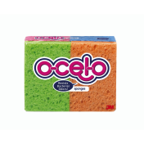
- 1 box of large (gallon-size) plastic zip bags
- 1 ream of copy paper
- 1 small pack of sponges (the O-cel-o brand)
Please label all supplies with your child’s name

Have a great summer!
Mrs. Pino

