Christopher Columbus Elementary School
3rd Grade Supply List
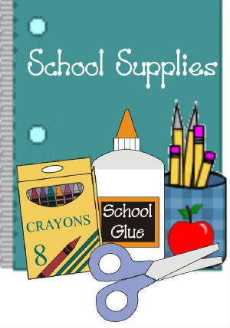
- Colored Pencils
- Washable Crayola markers
- Scissors
- (3) glue sticks**
- Post-it notes**
- Ruler (with inches and centimeters)
- Package of Wide Ruled paper
- (3) packages of 12 pencils (plain #2)**
- Pencil Sharpener
- Erasers (eraser tops and 1 large eraser)
- Pencil Box
- (1) 1-inch binder (white)
- Composition notebook
- (4) 1-subject spiral notebooks
- (5) Folders (3-hole punched to go into the binder)
- 2 boxes of tissues**
- 1 bottle of hand sanitizer**
- 1 Clorox disinfecting wipes**
- 1 roll of paper towels**
- 3 skinny black Expo markers**
- {OPTIONAL} 1 box of gallon OR quart size zip lock bags**
** Supplies will be collected for classroom use.
Please have an extra set of supplies at home for when they do homework.

