What’s New in 202? Week of March 23, 2020

Dear Second Grade Families (and students),
Please read the following carefully.

I hope everyone is staying safe and well. I’m sure that for all of us…working from home (this past short and hectic week) has been a great learning experience! But we must stay strong, proactive, productive, and positive!

Parents, many of you I’m sure, have been nagivating the internet—researching for projects and ideas to keep your student/s productive. Please feel free to continue doing that. However, keep in mind that our purpose (as teachers, especially during this school closure period) is to provide students with work they have been taught (and are familiar with) so they can continue reviewing (or practicing) the skills they need to know. Therefore, I am kindly asking all of my parents, to please supervise the work students complete. I am recommending you follow the plans being provided (on a weekly basis). The plans aren’t perfect, but they are to be used as a guide for “student work.” Students can try completing the activities independently, or with a family member’s asistance. I will be holding all of my second graders accountable for the work they do. Students will be given a participation grade. You can email me or text me a picture sample of any work your student has completed (as evidence). I’ve already had parents doing that. Thank you Thank you!! Keep in mind that all teachers also have access to their students’ “log in” time on Iready and Raz kids. We know who is actively using the account and who isn’t working enough.

Don’t hesitate to email or text me your questions, or concerns.
Again, the plans aren’t perfect, but students need to try the activities and spend some time during the day staying productive.

I will continue to make phone calls as well.
MEPIno@cps.edu Cell # 224 361-1983
An Overview of this upcoming week:

For this upcoming week (the week of March 23, 2020)
Reading…
- Students need to continue logging on to Iready.com to practice the necessary “language arts skills.”
- Students can continue logging on to Razkids.com to read informational books, and ficional books (for enjoyment and reading practice)
- Students were given the “pink” Sing, Spell, Read, and Write workbook. Students will complete 2 to 3 pages a day. (2 minimum). This is a good workbook, because the student is engaged in reading, writing, and learning new vocabulary.

Students must complete these pages (thoughtfully). They need to “go back” to reread or recheck their work.
Did the student understand the directions? Is he guessing? Did the student rush throught the work pages? How is the student’s writing? Is it messy, is it neat? These are the kinds of observations you need to make as the students works.

If the work pages appear difficult, then a family member should help the student. But, the student should try to complete some parts on his own. It is always good to “challenge” all students.

- Students were also given some books (smaller books) by me.
What are some skills the students need to practice when they read?
- Sight words fluency (can the student read all the sight words fluently?)
- Reading accuracy (Is the student paying attention to punctuation marks and reading with expression?)
- Reading for understanding (Does the student understand the content? Does he understand what he/she is reading? Is the student able to retell the content in his or her “own words?”
- Asking questions (Can the student formulate questions about the content to check for understanding?)
For students who need more practice with simple, short reading exercises, and phonics practice (or letter sounds), here is a website I like using for extra reading practice with those “special letter sounds” (in the English language).

Visit: Theschoolhouse.us/lessons click on link: Free Phonics Lessons.

(My recommendation is that students go down to the “Lessons” section of the page.
Students can do 1 or 2 lessons in a day. (1 lesson would be fine), but you decide as the parent.

For example: on Monday, the students can click on Lesson 1 “Short a.”
(In this lesson, the students will read both easy and difficult words that contain the “short a” sound. In fact, your child can spend extra time writing sentences using any of the words on this lesson. They can use “short a” words to write a story, or write a letter. You decide with your child.

- Another fun reading activity for students who need more practice with their letter sounds
Click on…Paper plate sunflower word family activity (Video)

- Another website for (research projects) the one suggested of “Famous women” or… “Famous Men.”
www.duckster.com/biographies

Writing:
This week’s focus: Facts and opinions
We learned about Facts and opinions earlier in the school year. This would be a good time to review what a “fact” is and what an “opinion” is.
Look at the writing activities I have listed. Each page (of activities) has the date for the day of the week. Try doing the acitivity independently, but remember to ask a family member to help if you need assistance.
Again, please text or email me a picture of an activity you have completed. This would justify your work responsibility.

Social Studies:
In the second grade classroom there is a large world map—covering an entire wall. The second graders enjoy interacting with that “wall map” looking up places in the world-where historical events have occurred. In fact, some students in class have started reading the “I Survived” series (by author: Lauran Tarshis) to learn more about such events. The students also use a dry-erase marker to draw pictures, or images that relate to a country, continent, or simply to look up their country of origin.

I have created some activities that will help students “revisit” and “review” the…
*names of the continents *names of some countries (the ones that represent the students in our second grade classroom), and *landmarks of places around the world.

The second grader can work independently, or with another family member on the activities which I’ve included. The student can repeat any of these activites throughout the day or throughout the week. The more the child practices, the more confident he’ll become in this learning.

Another recommended activity (in the social studies packet ) is the “Riddle reading cards.” These cards can be treated as “reading practice,” to build word knowledge or vocabulary, but also for building geographical knowledge. The student can print these, cut out the cards and read them any time, any place. Parents can also decide how the child should use the cards.

Lastly… The “Famous Women” project (to honor Women’s History month) or Famous Men” Look for the project under the lesson plans for week 2.

Math:

- Students need to continue logging on to Iready.com to practice the necessary “math skills.” Iready math must be completed every day of the week (a minimum of 1 lesson per day). Besides the Iready math… Students can do one of the following activities:

Activity 2 Students can also practice using the deck of cards to play “Top It” (addition) or “Top it” subtraction. I included the directions of Top it addition below.

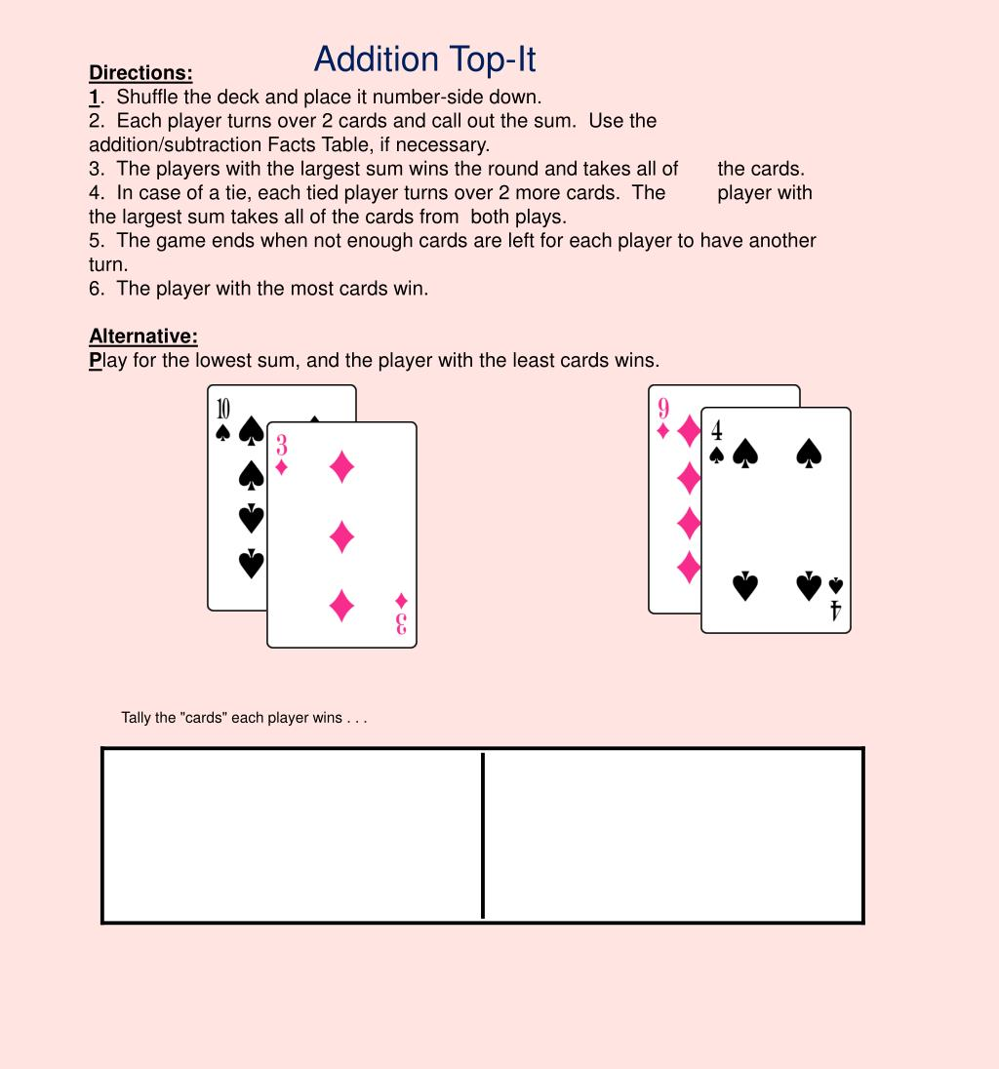

You can also go to the Dollar Tree (Dollar store) to purchase more cards.

Activity 3 (this is an optional activity. Some students need more practice than others) This is to review Place value.
Students need paper to make these cards. They can make 10 to 20 cards. Students can use both sides. They will divide each card into 2 columns. One label will be the “tens” label (on the left), and one label will be the “ones” (on the right). The Student can write any 2 digit number. (like 18, or 24). For the number 24. The student must remember to place the “2” in the “tens” label, and “4” in the “ones” label. Then, the student will draw the number of towers to match the “tens” digit, and the number of “cubes” to match the “ones.” Look at the examples below. Students should keep the cards they made to review them later.

The towers represent (a tower of 10 small cubes)
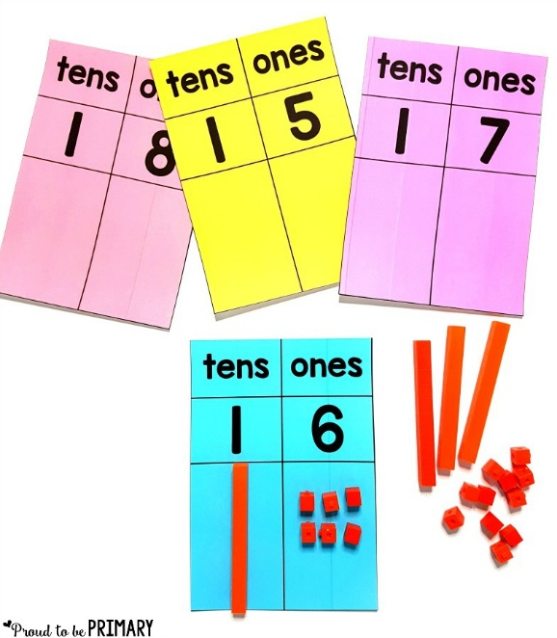

The “Gallon Man” Activity:

Look below

Here’s a great math project that the younger students enjoy
Important: it might take a while to collect all necessary supplies, but when you do collect them get started!
The purpose of this activity is to teach math lessons on “capacity.” The parent can help and ask questions along the way? Example: How many cups are there in 2 gallongs? Etc. etc…
Or… If we are planning a party, and we are inviting 25 kids, how many gallons of juice do you think we’ll need?

The second grader will learn ….
*how many cups in a gallon
*how many cups in a half gallon
*how many cups in a quart
*how many cups in a pint (pronounced—like “pine”)
*and finally the capacity of a “cup.”

What does a gallon look like? | What does a “half” gallon look like? | What does a “quart” look like? | What does a “pint” look like? | What does a “cup” look like
holds 16 cups  Of liquid | Holds 8 cups | Hold 4 cups | Holds 2 cups | or…
