Writing:
Spend a minimum of 20 minutes writing about the pictures you see below. Write a short story.

Tell the story of what happened to this girl.
Remember to use important words like: nouns, verbs, adjectives, and Tier 2 vocabulary you know
(like: ordinary, extraordinary, prevent, avoid,)
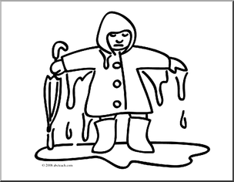

___________________________________________________________________________________________________
___________________________________________________________________________________________________
__________________________________________________________________________________________________
_____________________________________________________________________________________________________
_____________________________________________________________________________________________________
_____________________________________________________________________________________________________
_____________________________________________________________________________________________________

_______________________________________________________________________________________________________
________________________________________________________________________________________________________

Tell the story of what happened to this boy.
Remember to use important words like: nouns, verbs, adjectives, and Tier 2 vocabulary you know
(like: ordinary, extraordinary, prevent, avoid,)















