Writing: (for Thursday)
Spend a minimum of 20 minutes writing about the pictures you see below. Write a short story
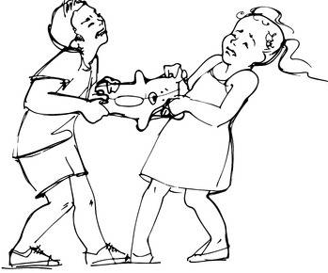
Tell the story of what happened to this girl and boy.
Remember to use important words like: nouns, verbs, adjectives, and Tier 2 vocabulary you know
(like: ordinary, extraordinary, prevent, avoid,)

Tell the story. Every good story has a Title, a beginning, middle, and end.
These are some words you can use for the beginning, the middle and the end.

Words you can use to start your story:  One day…  The other day when  Last week…  Yesterday…  Last Friday (or other day) | Words you can use in the middle of your story:  Then…  Next….  Later…  After this… | Words you can use at the end of the story…  Finally…  At last…

Look at the examples below

The Missing Toy

Last Friday after school, Robert invited his friend Tom to his house to play. Robert wanted to show Tom the cool toy shark he received on his birthday.
Then, _______________________________________________________
___________________________________________________________
___________________________________________________________
After this ___________________________________________________
___________________________________________________________
____________________________________________________________
Finally ________________________________________________________
_____________________________________________________________
_____________________________________________________________

To make your story sound more exciting, you can add “” (quotation marks, and words that show emotions to show how the characters are feeling. Here is a short example:

The Missing Toy
“Oh no! Where’s my new toy shark?” Robert asked. The toy shark was his favorite toy, and it was the one he had gotten on his birthday.
Robert thought his sister had it in her room. So, before he went to school, he reminded his sister to leave it in his room.

Friday (writing assignement)

Opinion Writing Piece
Choose from one of these 2 topics. You can print this, or write using a notebook.
- Should students be allowed to bring their own snack to school?
Or…
- Should students be allowed to bring their pets to school on field day?

Remember, you can being by asking a question. Look at the example below, and complete it

Do you think students should be allowed to bring their own snack to school?
In my opinion______________________________________________________
________________________________________________________________
Reason 1
I think students should bring their own snack because _______________________________________________________________
________________________________________________________________
________________________________________________________________
Reason 2
Another reason why students should bring their snack is ________________________________________________________________
________________________________________________________________
_________________________________________________________________
__________________________________________________________________
Reason 3
Also, I feel that _____________________________________________________
__________________________________________________________________
__________________________________________________________________
Conclusion
For all these reasons, I believe it’s important for students to bring their lunch to school. And…_____________________________________________________
_________________________________________________________________

