Dear Second Graders,
Writing activities for the week of March 23, 2020
Welcome to a second week of “writing!” I am recommending the following writing activities to “review” facts and opinions.
Do you remember what a fact is?
A fact is a statement that is real or true. It is something you can prove (because you can see it, touch it, feel it, hear it, or smell it)
Here is an example of a fact.
Birds have wings. 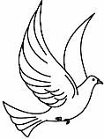
We know this is real. We know it is true. We can prove it by looking at a bird’s wings on its body, or by looking at how the bird uses its wings when it flies.

Now, let’s look at an opinion. Do you remember what an opinion is?
An opinion tells a person’s thoughts, and feelings. It tells how people think or feel about something. And remember, other people might disagree with a person’s thoughts or feelings. Here is an example of an opinion.
Birds are more interesting animals than mammals or reptiles!
This is how a person feels or thinks about birds. But not all people feel or think that way about birds. Other people might prefer mammals or reptiles instead of birds.
Complete the “writing” activities on Facts and opinions for this week. You can print these sheets, or use paper and pencil.
Monday (March 23, 2020)

Facts and Opinions
Directions: Carefully look at the picture. Read the sentences. Write Facts if the sentences are facts. Write opinions, if the sentences state an opinion. Practice writing more facts and opinions about the picture. Remember, a fact is a statement that is true, or real. An opinion tells what you think, or feel about the picture. But remember: You don’t always need to say, or see the words: I think, I feel, I believe, or… In my opinion . Read very carefully to find the opinion sentences. Sometimes they can be “tricky.” Look at the example below:
Example: Which one is the fact and which one is the opinion? Can you tell the difference?
1--A boy and girl play on the slide.
2-- Girls are more daring at using the slide (than boys)!

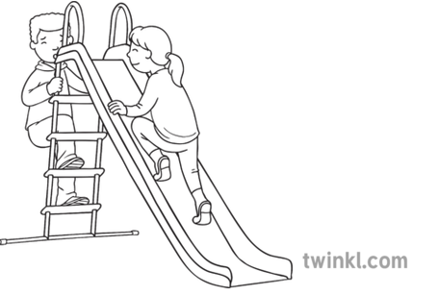

1-Playing in the park is the best outdoor activity for kids!
2-All kids are able to play in the park!
3-The boy climbs safely!
4-The girl is faster at climbing than the boy!
Now you try it. Label your facts and opinions

Facts and Opinions
Directions: Carefully look at the picture. Read the sentences. Write Facts if the sentences are facts. Write opinions, if the sentences state an opinion. Practice writing more facts and opinions about the picture. Remember, a fact is a statement that is true, or real. An opinion tells what you think, or feel about the picture. But remember: You don’t always need to say, or see the words: I think, I feel, I believe, or… In my opinion . Read very carefully to find the opinion sentences. Sometimes they can be “tricky.” Look at the example below:
Example: Which one is the fact and which one is the opinion? Can you tell the difference?
1—Summer is the best time of the year to ride a bike!
2—Two people ride the bike along the street.

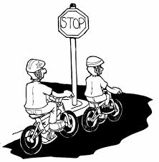

1—A helmet protects bike riders.
2—The wheels on the bike are round.
3---Older people are better at riding bikes

Now you try it. Label your facts and opinions

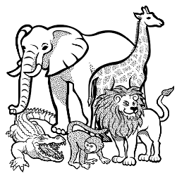 Facts and Opinions
Writing activity for Tuesday, March 24, 2020
The sentences come from the website: www.superteacherworksheets.com (facts and opinion)
You can print this sheet, or use paper and pencil (or a notebook) to copy the work.
Remember: A fact tells information that is real or true. An opinion tells how someone feels about something.
Write “fact,” or “opinion” on the line. You can add more facts and opinion.

- ________________ A giant tortoise can live to be over 150 years old.
- ________________ Jennifer saw a zebra at the zoo.
- ________________ A polar bear is the most fun animal to watch.
- ________________ Parrots are prettier than blue birds.
- ________________ Elephants eat grass and leaves.
- ________________ Bald eagles usually lay one or two eggs at a time.
- ________________ Blue whales are the largest animals in the world.
- ________________ A cheetah can run faster than a lion.
- ________________ Everyone should go to see the new gorilla habitat.
- _______________ Koalas usually sleep during the day.
- _______________ Canaries sing beautifully.
- _______________ The bats in the cave are very scary.
- _______________ Snakes do not make good pets.
- _______________ Chimpanzees can climb to the tops of trees.
- _______________ Hummingbirds are the only bird that can fly backwards.
- _______________ A rhinoceros can be very difficult to take care of.
- _______________ Crocodiles spend most of their time in saltwater.
- _______________ Pandas are black and white.
- _______________ Hippos are amazing animals to watch.
- _______________ A Komodo dragon is a reptile.

Candy  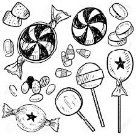 | Jet Plane 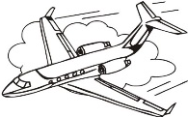
Facts:  1___________________________  ____________________________  2___________________________  ____________________________  Opinions:  1__________________________  ___________________________  2_________________________  ___________________________ | Facts:  1._________________________  ___________________________  2._________________________  ___________________________  Opinions:  1.__________________________  ___________________________  2._________________________  ___________________________
Write 2 or 3 facts and opinions about each of these topics. You can write more.
Writing Activity for Wednesday, March 25, 2020
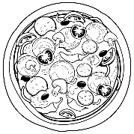 Pizza | T.V.
Facts:  1___________________________  ____________________________  2___________________________  ____________________________  Opinions:  1__________________________  ___________________________  2_________________________  ___________________________ | Facts:  1._________________________  ___________________________  2._________________________  ___________________________  Opinions:  1.__________________________  ___________________________  2._________________________  ___________________________
Writing about a family member (facts and opinions).
Thursday, March 26, 2020
Write the opinions on the reverse side (back side). Remember, you can also write in your notebook. You can continue writing more facts and opinions. 5 or 6 would be the minimum.
Pick a family member. Write 5 or 6 facts about that person. Then write some opinions about the person. For example:
brother

Fact: My brother has brown hair.

Opinion: My brother has the cutiest smile in our family!

You can print this sheet, or use paper and pencil (or notebook)
Facts:
1.____________________________________________________________________________
______________________________________________________________________________
2______________________________________________________________________________
________________________________________________________________________________
3______________________________________________________________________________
________________________________________________________________________________
4______________________________________________________________________________
_______________________________________________________________________________
5______________________________________________________________________________
Another activity you can try today (Thursday, March 26th)
Super Teacher Worksheets - www.superteacherworksheets.com
How to make the Cootie Catcher:
1.Cut out your cootie catcher and color it. Place the square faceup and fold and unfold the square in diagonals from corner to corner so you end up with x shaped creases.
2.Place the square facedown and fold each of the four corners in so the points meet in the center.
3.Turn the paper over so the flaps are now facedown. Fold each of the four corners in so the points meet in the center.
4.Fold the square in half from side to side, then unfold it. Fold the square in half from bottom to top.
red
blue
green
orange
5.Slide both thumbs and index fingers under the four flaps.
6. Pinch the top corners together with the thumbs and fingers under the flaps to form a point.
Su www.superteacherworksheets.com
How to play:
Facts and Opinions (Cootie Catcher)
1.Choose one of the colors printed on the outside square (red, blue, green, or orange).
2.Open and close (front to back and sideways) once for each letter in the color selected. For example: red would be opened and closed three times.
3.Choose and read one of the four fact or opinion statements shown inside and tell whether it is fact or opinion.
4.Lift the flap of the chosen question and check your answer.

Look below at the Example:

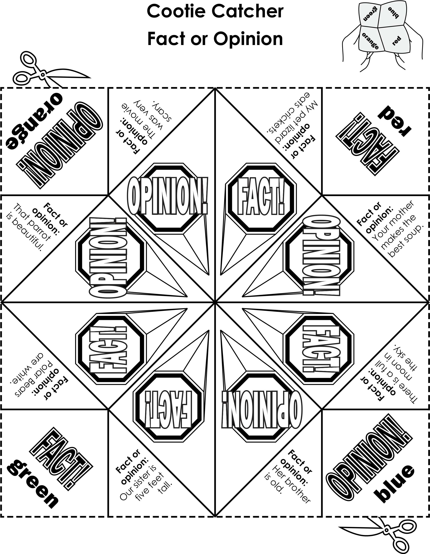

Friday, March 27, 2020 Facts and Opinions

1 2 3 4 5 6 7 8 9 10
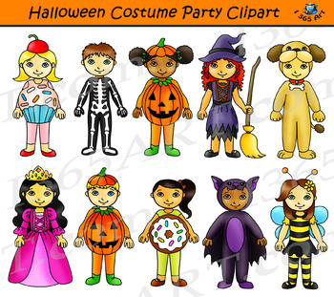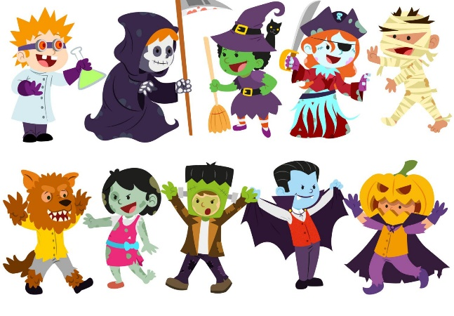
11 12 13 14 15 16 17 18 19 20

Writing Activity: (Halloween Costumes)
Today you will write facts and opinions about Halloween costumes.
Here is a way to do the activity. But you can select another way of completing this assignment. (You can complete this using a notebook).

Kid 1 Fact

Kid 1 is dressed like a cupcake with a cherry on top.

Kid 1 Opinion
Kid 1 is wearing the cutest costume because cupcakes are not scary and everybody likes cupcakes!

Another activity to do today is to write an opinion writing piece about your favorite Halloween costume, and tell the reasons why it’s the best, or your favorite.
Look at the example below:

Introduction
Do you like Halloween, and dressing up in your favorite costume? In my opinion, the mummy costume is the best you will ever see!

I think the mummy costume is the best because it’s so easy to make. All you really need is toilet paper. If you don’t have toilet paper at home, you could buy it at the Dollar Tree. It would be more expensive to buy a mummy costume at a regular costume store.

Also, it would be fun to have a friend or family member wrap you around in toilet paper. This is something you don’t get to do every day.

Another reason why a mummy costume is great is because you can also save the toilet paper and recycle it. You can put the toilet paper back in a box and use it for dusting, and cleaning.

A mummy costume is the best! It is easy to make without paying a lot of money. I can’t wait for Halloween to come!

Reasons

Conclusion

Now you try.

