Your Animal Book- (an informational book) project
Giraffes
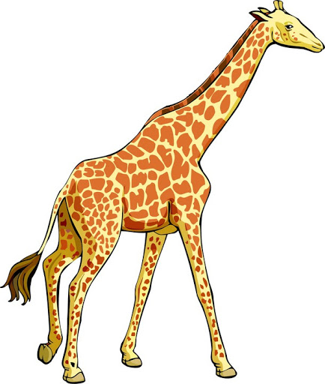
By Sue Smith
Illustrated by Sue Smith
Dear Second Grader,
In the classroom, you started working on an informational book.
The topic was a specific animal. You selected a specific animal to write about.

Take a look below.
1--You will see some websites to help you collect information about your animal. Your job is to try to gather as much information as possible. You probably already know some facts about your animal. You will write those facts.

2—Use the Chart below to write the facts you know, or the facts you will find (in those websites). Your parents can help you read the information. But you must do the writing.
3--These are some websites you can use to “research,” or find more information, facts, and details about your animal.
Some of these websites include “videos.”
With you parent’s permission, Google these websites, and try to collect as much information about your animal. Use the chart below to write the facts. Look at my example below.

1-Zooborns.com

2-Sandiegokids.org

3-Switchzoo.com

4-National geographic kids

5-Ducksters.com

6-Sandiegokids.org

7-Sciencekids.co.nz

Page 1
My Animal____________________________________
My animal…
Has… | Can… | Is…

Giraffe
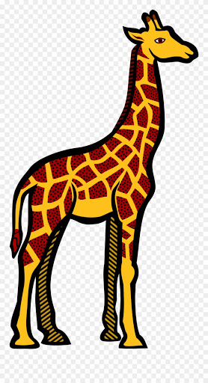

Has | Can… | Is…
-Long neck  -Fur on its body  -Spots (a spotted body)  -Small hears  -Long tail  -Long legs  -Large strong teeth  -Flat teeth  -have a backbone  (they are vertebrates)  -long tongue  -horns that are covered in fur | -Stay together in a herd (live together in groups) (A group of giraffes is called a herd)  -reach high things (like their food from trees) | -The tallest mammals on land.  -is gentle and calm  -a herbivore  because they have flat teeth-so they are able to chew plants and leaves  -is prey to other wild animals.

